Paper title (Arial, 11 pt, bold)
Author 1 (Name, Surname) (Arial, 10 pt)
Name of Institution, Country
E-mail: abc@xyz.com
ORCID: https://orcid.org/0000-0000-0000-0000
ROR: search for your institution link here https://ror.org/
Author 2 (Name, Surname)
Name of Institution, Country
E-mail: abc@xyz.com
ORCID: https://orcid.org/0000-0000-0000-0000
ROR: search for your institution link here https://ror.org/
Author 3 ***
Abstract. The abstract introduces the problem under study, its significance, the aim of the study, the methods, and the main results. The abstract should be between 1000-1500 characters in length and written in the language of the article. The abstract, keywords and JEL codes are in Arial font, size 10 pt. In the footer at the bottom of the first page, include the names of all authors and the date of submission. The text in the footer should be in Arial font at 7 pt.
Keywords: 3-5 keywords, separated by commas.
JEL Code: JEL codes 1 to 3 should be assigned according to the entity descriptor of the economic classification https://www.aeaweb.org/econlit/jelCodes.php?view=jel. Codes are separated by commas.

Introduction (Arial, 10 pt, bold)
This template provides information for authors on the formatting requirements and specifications for the article they are preparing. The recommended length of the article is approximately 3000-8000 words. The font used throughout the article should be Arial, size 10, line spacing 1.15, paragraph spacing 6 pt. The text should be justified on both edges, with the indentation of the first line set to 0 cm.
This template is designed to fit A4 paper size (21 cm × 29.7 cm) in MS Word format. Examples of the font style are given throughout the template, with details in brackets.
The article's introduction should reveal the relevance and novelty of the topic, formulate the research's aim, define the research's object, describe the research methods, and indicate the extent of research on the topic. The introduction may also present the scientific problem to be solved, the possible solutions, and the research limitations. In addition to the aim of the study, the article may include research objectives.

1. Article structure (Arial, 10 pt, bold)
The required basic elements of a paper are an abstract, keywords, an introduction, a body of the paper, and conclusions, followed by a list of references. The structure of the article’s text depends on the author's chosen topic and is not restricted. The following classical structure is recommended, though not mandatory: 1) analysis of the literature on the topic; 2) study methodology; 3) analysis and evaluation of the study results. The subdivision of chapters and other technical formatting requirements are provided in Chapter 2.

2. Technical specifications of the article

2.1 Sub-sections (Arial, 10 pt, bold)
Where appropriate, sections of the article may be broken down into smaller structural parts such as sub-sections. However, it is not recommended to subdivide a subsection into even smaller parts. For emphasis or highlighting, certain areas can be highlighted in Bold or Italic.
Words, phrases, or various names that are frequently used may be abbreviated. Commonly understood abbreviations do not require further explanation (e.g., kW, Dr., Oct., etc.). Other abbreviations or acronyms, which are formed in various ways, should be explained in the text the first time they are used, or a list of them with explanations can be provided at the end of the article (e.g., chief executive officer (CEO)).
To avoid confusion of terminology, a term used in the text should be followed by the term in the original language in brackets, indicating the language and the term should be written in Italic style (e.g., cosmetic balance sheet (German bilanzkosmetik)), etc.

2.2 Accessibility of visual aids for the blind and partially sighted

The European Accessibility Act that came into effect in 2025 mandates that e-publications be accessible to all individuals, including those who are blind or partially sighted. The publishing house will prepare the electronic files accordingly. However, tables and illustrations within the article must be described in a manner that is comprehensible to blind individuals. For guidance on how to create these descriptions, refer to the Guide to Image Descriptions – AccessiblePublishing.ca. Descriptions should be placed directly below the table or illustration, formatted in [square brackets]. While these descriptions will not be visible in the final version of the publication, they need to be accessible to language editors and layout artists during the production process.

2.3 Visual aids
It is recommended to present the results of the study in figures or tables when systematizing, comparing, or summarizing the information or presenting the results. The figure number and title should be placed below the figure.
Figures should be clear and legible, in JPEG, TIFF, or PNG formats, and may be in black and white or colour (see Figure 1).

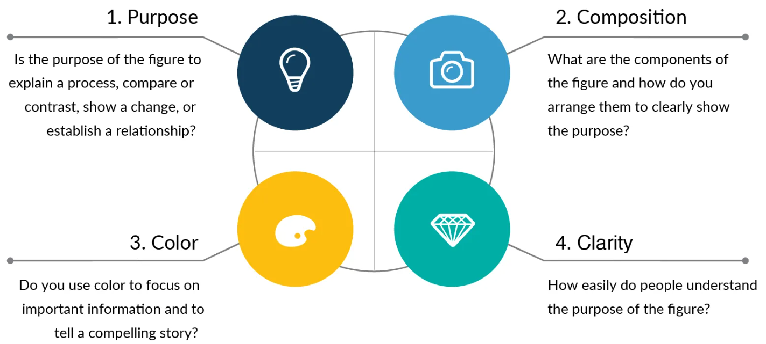
Figure 1. How to create a quality image
Source: Simplified science publishing (2024)

[The figure illustrates four essential rules for creating a high-quality figure: 1) clearly state the purpose of the figure, 2) arrange the elements of the figure appropriately, 3) use colour to highlight important information, 4) present the information in a clear and easily understandable manner. Each rule is represented by a coloured circle, each featuring a corresponding symbol that signifies purpose, composition, colour, and clarity.]
Tables in the work shall be in Arial font, size 10 pt, single line spacing. Tables are presented as editable text and not as pictures. The table number and title are written above the table (see Table 1).

Table 1. Guidelines for presenting information in figures and tables
No. | Description of the guidelines
1 | Tables and figures should be included in the text at the appropriate place in the article.
2 | Figures and tables must be logically titled.
3 | Each figure or table must be followed by a reference to the source(s) or an acknowledgement that the material has been compiled by the author(s).
4 | Figures and tables should be numbered separately and consecutively using Arabic numerals.
5 | Figures and tables should be aligned on the left-hand side of the page.
6 | Leave one 10 pt blank line before and after the figure or table.
7 | Visual aids should not be too crowded or too long. Symbols must be clear and easily distinguishable.
8 | Visual aids should not duplicate textual information.
Source: compiled by authors
[The table below provides eight basic guidelines for presenting visual material to help authors present high-quality and well-formatted figures and tables.]

Each figure or table should be followed by a description, an explanation, and the authors' main insights.

2.4 Equations and statistical rules
The formulas or models used to perform the calculations should be included in the description of the research strategy. Mathematical formulas or other mathematical expressions should be inserted in the text in a separate paragraph. Formulas should be written using the Microsoft Equation formula builder and numbered consecutively with Arabic numerals in brackets, aligned to the right margin:

$y=ax+b$; (1)
here:
y – is the first variable;
a – is the second variable;
x – is the third variable;
b – is the fourth variable.
The statistical methods and models used should be presented with their descriptions and full parameters.

2.5 In-text citation
In-text citation of sources should follow APA citation style (https://apastyle.apa.org/style-grammar-guidelines/references/examples). Some examples of citations are provided in Table 2.

Table 2. Guidelines for citing sources
Source | In the reference list | In-text
E-journal article (with DOI), one author | Dhillon, P. (2022). How to write a good scientific review article. The FEBS Journal, 289(13), 3592–3602. https://doi.org/10.1111/febs.16565 | Dhillon (2022)...  Or ...(Dhillon, 2022)
Article in a printed journal, two authors | Jusytė, J., & Kamarauskienė, I. (2014).Viešojo sektoriaus subjektų finansinių ataskaitų santykinė analizė: teoriniai ir praktiniai aspektai. Buhalterinės apskaitos teorija ir praktika, 16, 63–77. | Jusytė and Kamarauskienė (2014)...  Or ...(Jusytė and Kamarauskienė, 2014)
E-journal article (with DOI), two authors | Watts, R.L., & Zimmerman, J.L. (1990). Positive accounting theory: a ten year perspective. Accounting Review, 65(1), 131–156. https://www.jstor.org/stable/247880 | Watts and Zimmerman (1990)...  Or ...(Watts and Zimmerman, 1990)
Three or more authors | LaPlaca, P., Lindgreen, A., & Vanhamme, J. (2018). How to write really good articles for premier academic journals. Industrial Marketing Management, 68, 202–209. https://doi.org/10.1016/j.indmarman.2017.11.014 | LaPlaca et al (2018)…  Or …(LaPlaca et al. 2018)
Same author(s), same year | Tamulevičienė, D., & Mackevičius, J. (2019a). Išlaidų klasifikavimo informacijos naudojimas įvairiems įmonių veiklos tikslams. Informacijos mokslai, 86, 157–173. https://doi.org/10.15388/Im.2019.86.31  Tamulevičienė, D., & Mackevičius, J. (2019b). Methodology of complex analysis of tangible fixed assets. Entrepreneurship and Sustainability Issues, 7(2), 1341–1352. https://doi.org/10.9770/jesi.2019.7.2(38) | Tamulevičienė and Mackevičius (2019a) …  Or … (Tamulevičienė and Mackevičius, 2019a)  Tamulevičienė and Mackevičius (2019b) …  Or … (Tamulevičienė and Mackevičius, 2019b)
A book | Tracy, T.C. (2024). How to Read a Financial Report: Wringing Vital Signs out of the Numbers. John Wiley & Sons. | Tracy (2024)...  Or ...(Tracy, 2024)
A group or organisation | American Psychological Association. (2024). Common Reference Examples Guide. https://apastyle.apa.org/instructional-aids/reference-examples.pdf | American Psychological Association (2024)…  Or …(American Psychological Association, 2024)
Website | Simplified science publishing. (2024, September 3). Internet addiction. How to Make good figures for scientific papers. Retrieved from https://www.simplifiedsciencepublishing.com/resources/how-to-make-good-figures-for-scientific-papers | ...(Simplified science publishing, 2024)
Source: compiled by authors based on Mendeley (2024), American Psychological Association (2024)
[The table below provides guidelines for citing sources in APA style. It is organised into three columns: the first column lists types of sources, the second column provides examples of how to cite each source in the reference list, and the third column shows how to cite each source in the text. This information is designed to assist authors in formatting bibliographic references accurately and ensuring consistent citation practices.]

When preparing your manuscript, pay attention to using quality sources. Choose high-level scholarly publications for citations and avoid inappropriate citations, unrelated references, or unreviewed online articles, etc.

3. Discussion and limitations of the study
After presenting the main results of the study, it is recommended that the implications of the results be discussed. The discussion should not focus on restating the results but on providing a critical assessment of them. The results can be compared with the work of other researchers. If the results of the study are contrary to the work of other researchers, this should also be reflected in the discussion, which should address why these results were obtained and the reasons behind them.
It is also helpful to discuss the limitations of the study and assess what further research would be needed to answer the questions raised by the results or to explore the research problem further.

Conclusions (recommendations, discussion questions)
1. This chapter presents the detailed conclusions of the study. If the paper includes objectives, it is advisable to relate the conclusions to the objectives.
2. The contribution of the research to the advancement of the field and its scientific novelty should be highlighted.
3. Avoid listing results or repeating statements from the discussion.
Acknowledgement, explanation, additional information
In this section, you can thank individuals who have contributed to the manuscript but are not co-authors (such as providing technical assistance, help with writing, or proofreading). You can also acknowledge the institution that funded the research or provided a grant or scholarship.
Explanatory notes or additional information related to the preparation and publication of the paper can be provided. Possible links or lack of links should be explained in the event of a conflict of interest. Additionally, if artificial intelligence was used at any stage of the work, this must be disclosed in this section. It should specify which parts of the study, to what extent, and what kind of artificial intelligence was used.

Authors' contributions

When there is more than one author, the contribution of each author should be indicated according to the CreDiT criteria: conceptualization, data curation, formal analysis, funding acquisition, investigation, methodology, project administration, resources, software, supervision, validation, visualization, writing - original draft, writing - review and editing (CRediT_Taxonomy_Terms_and_Definitions_list)

Author 1 (name, surname): indicate the author's contribution according to the CreDiT criteria. Author 2 (name, surname): indicate the author's contribution according to CreDiT criteria. Author 3 ***.

References
The text should cite all scientific publications on which your work is based. The alphabetical list of sources and references should follow the international APA referencing system (see Table 2). Sources by the same author should be listed chronologically by date of publication. Use Arial font, size 9 pt, line spacing 1.15, paragraph spacing 6 pt, with text aligned to the left margin and no indentation for the first line of a paragraph.
American Psychological Association (2024, September 4). Reference guide for journal articles, books, and edited book chapters. Retrieved from https://apastyle.apa.org/style-grammar-guidelines
Dergaa, I., Chamari, K., Zmijewski, P., & Saad, H.B. (2023). From human writing to artificial intelligence generated text: examining the prospects and potential threats of ChatGPT in academic writing. Biology of Sport, 40(2), 615–622. https://doi.org/10.5114/biolsport.2023.125623
Dhillon, P. (2022). How to write a good scientific review article. The FEBS Journal, 289(13), 3592–3602. https://doi.org/10.1111/febs.16565
LaPlaca, P., Lindgreen, A., & Vanhamme, J. (2018). How to write really good articles for premier academic journals. Industrial Marketing Management, 68, 202–209. https://doi.org/10.1016/j.indmarman.2017.11.014
Mendeley (2024, September 4). APA format citation guide. Retrieved from https://www.mendeley.com/guides/apa-citation-guide/#1_Ref_List
Simplified science publishing (2024, September 04). How to make good figures for scientific papers. Retrieved from https://www.simplifiedsciencepublishing.com/resources/how-to-make-good-figures-for-scientific-papers

Author 1 (Name, Surname): information about the author: education, scientific and pedagogical title(s), fields of scientific interest, the name of the institution represented, the position held by the author, the address of the institution.
Author 1 (Name, Surname): information about the author: education, scientific and pedagogical title(s), fields of scientific interest, the name of the institution represented, the position held by the author, the address of the institution.
Author 3 ***

