Paper Title – Left, Normal, do not use abbreviations here

Author’s full name 1
Institutional affiliation followed by single line spacing - Department/Organization
Address
Email
ORCID iD:
Research interests:

Author’s full name 2 (delete if not applicable)
Institutional affiliation followed by single line spacing - Department/Organization
Address
Email
ORCID iD:
Research interests:

Abstract. Limit of 1,000–1,200 characters. Justified, Lower case.
Keywords: up to 5 keywords or descriptors that clearly describe the subject matter of the article. No quotations within keyword. Please separate keywords with semicolon, not by comma.

[Note: Use Unicode (UTF-8) fonts for the article.]

Introduction. Heading Level 1

Introduction of the article shall formulate research aim and objectives, define research object, indicate the extent of research on the subject, research methods, relevance and (or) novelty. Body Text. No gap between paragraphs. One blank line before subsequent Level one headings.
- Heading Level 1
The main body of the article is dedicated to the presentation of research conducted by the author(s). The research material should be divided into smaller parts. Each subdivision should have a subheading.

1.1 Heading Level 2
Citations in the text are referred to in the text by giving the author’s surname, the year of publication and the page numbers, e.g., As Harvey (1992, p. 21) said, “good practices must be taught” and so we...
- Heading Level 1. Text presentation
Proper names should be spelt in accordance with the latest orthographical norms. When mentioned for the first time, a personal name should include both first and last names, but when repeated the name initial and family name is sufficient. If the work is written in another language, proper names should be written according to the spelling rules of that language.
When books or periodicals published in foreign languages are mentioned in the paper, their titles are to be put in the original language. If their titles are translated or abbreviated, their original title should be indicated in brackets or in footnotes. All titles in footnotes are to be written in their original language.
Quotations from fiction should be written in their original language and their original spelling and punctuation should be preserved.
Block quotes, indented 1.5 cm from left and right. Fully justified. (Citations are referred to in block quotes by giving the author’s surname, the year of publication and the page numbers).
Moreover, it is worth noticing that translating metaphors is a difficult task insofar as
[t]here is no simplistic general rule for translation of metaphor, but the translatability of any given SL metaphor depends on (1) the particular cultural experiences and semantic associations exploited by it, and (2) the extent to which these can, or not, be reproduced non-anomalously in TL, depending on the degree of overlap in each particular case (Dagut, 1976, p. 32).
Citations from fiction in foreign languages may be translated in footnotes, while quotations from scholarly works are expected to be translated.
Thus, according to Michelucci (2001, p. 25),
[a] symptomatic emphasis on single parts of the body is also often witnessed in the works of the visual and literary avant-garde. Such emphasis suggests a rupture between part and whole, and can be seen to represent the fragmentation of the modern world and the loss of vital unity between man and nature.
Titles of books, journals and other periodicals should be italicized. Titles of other works that are not separate publications are to be given in quotation marks.

3. Heading Level 1. Figures and tables
Upon submission of an article, authors are requested to include all tables and figures in the main file of the manuscript. Tables and figures should not be submitted in separate files. All tables and figures should be cited consecutively in the text.
Table 1. Table captions should always be positioned above the tables
Heading level | Example
Title (left) | Lecture Notes
1st-level heading | Introduction. Conclusions. Acknowledgments. Sources. References
2nd-level heading | 2. Printing Area. Text follows

Please use the Microsoft Word Table function to make tables; you may need to revise any tables that are not created using this function. Tables should include a title, and footnotes and/or legend should be concise. Include tables in the submitted manuscript as a separate section. When creating tables, please adhere to the following guidelines:
do not submit tables in Excel or PDF format. Do not place an Excel table in a Word document;
format tables with Word's Table function; do not use tabs or spaces to create a table;
tables should be in black and white; rows and columns should not be shaded;
do not use line breaks or spaces to separate data within a cell. Use separate cells for all discrete data elements within a table;
number distinct tables as Table 1, Table 2, Table 3, etc., rather than as Table 1a, Table 1b, Table 1c, etc.;
if bold or italic font is used within a table to indicate some feature of the data, please give an explanation of its usage in the legend;
all abbreviations within a table must be defined in the table legend or footnotes.
It is essential that all illustrations are as clear and as legible as possible. Vector graphics – instead of rasterized images – should be used for diagrams and schemas whenever possible. Please check that the lines in line drawings are not interrupted and have a constant width.
Grids and details within the figures must be clearly legible and may not be written one on top of the other. Line drawings are to have a resolution of at least 800 dpi (preferably 1200 dpi). The lettering in figures should not use font sizes smaller than 6 pt (~ 2 mm character height). Figures are to be numbered and to have a caption which should always be positioned under the figures, in contrast to the caption belonging to a table, which should always appear above the table.

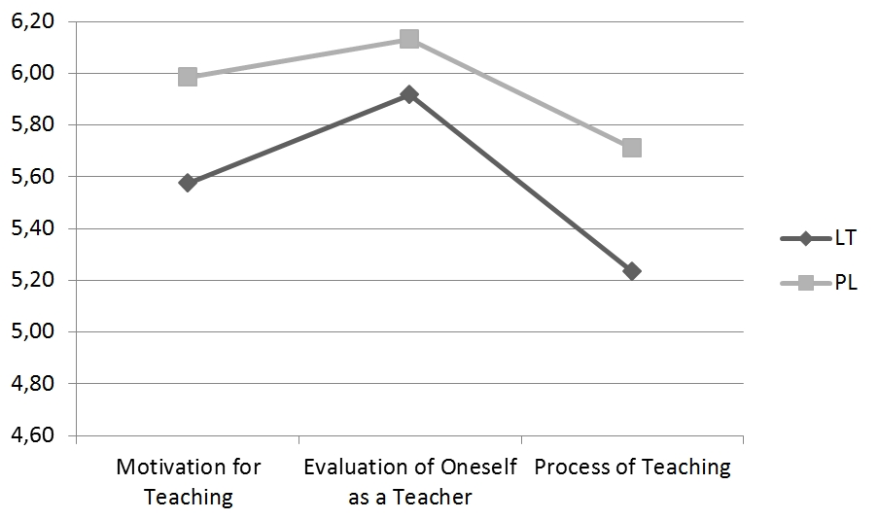
Fig. 1. Figures and tables should have a caption immediately below them.

If captions are short, they are centered between the margins. Captions that do not constitute a full sentence, do not have a period.

Conclusion. Heading Level 1
Detailed research conclusions should be formulated separately. The conclusions can be numbered.

Acknowledgments
Acknowledgments (optional) should be placed at the end of the paper before the references and may include supporting grants, presentations, and so forth. If the paper has formerly been presented at a conference then this should also be acknowledged in this area.

Sources
Rowling, J. K., 2000. Harry Potter and the Goblet of Fire. London: Bloomsbury Publishing.

References
The article is followed by the list of references. Other appendices can be added if necessary. References are arranged in alphabetical order by authors’ surnames. References in Cyrillic or non-Latin alphabet must be transliterated. If the source has DOI, it must be specified.
Arts Council England 2018. Freedom of expression guidance. [pdf] Available at: <https://www.artscouncil.org.uk/advice-and-guidance-library/freedom-expression-guidance> [Accessed 19 March 2020].
Boughton, J. M., 2002. The Bretton Woods proposal: a brief look. Political Science Quarterly, 42(6). Abstract only. Available at: ARU Library website <http://library.aru.ac.uk> [Accessed 12 June 2005].
Carvalho, P., Sarmento, L., Silva, M., Oliveira, E., 2009. Clues for detecting irony in user- generated contents. TSA ‘09 Proceedings of the 1st international CIKM workshop on Topic-sentiment analysis for mass opinion. Available at: <https://www.researchgate.net/publication/254304133_Clues_for_Detecting_Irony_in_User-Generated_Contents> [Accessed 1 October 2020]. https://doi. org/10.1145/1651461.1651471.
CEA, 2019. The Commission on English Language Accreditation. [pdf] Available at: <http://www.cea-accredit.org >
CEDT, 2006. Collins English Dictionary and Thesaurus. 4th ed. Glasgow: HarperCollins Publishers.
Clinton, H., 2016. Transcript of Hillary Clinton’s speech at Ohio State. 11/10/2016. The Columbus Dispatch. [online] Available at <http://www.dispatch.com/content/stories/local/2016/10/11/hillary-clintons-speech-at-ohio-state.html> [Accessed 15 November 2018].
Coulson, S., 2001. Semantic Leaps: Frame Shifting and Conceptual Blending in Meaning Construction. New York and Cambridge: Cambridge University Press. https://doi.org/10.1017/cbo9780511551352.
Verhoest, K. S., Van Thiel, G., Bouckaert, P., Basingstoke, P. eds., 2012. Government Agencies. Practices and Lessons from 30 Countries. UK: Palgrave / Macmillan.
Hyland, K., 1998. Persuasion and context: The pragmatics of academic metadiscourse. Journal of Pragmatics, 30(4), pp. 437–455. https://doi.org/10.1016/S0378-2166(98)00009-5.
Italie, H., 2009. John Updike, 1932–2009: Literary star leaves a rich legacy. Seattlepi.com. Available at: <https://www.seattlepi.com/ae/books/article/John-Updike-1932-2009-Literary-star-leaves-a-1298596>. [Accessed 1 December 2016].
Krenke, A. N. and Khodakov, V. G., 1966. O svyasi povercknostnogo tayaniya lednikov s temperaturoy vozdukha [On the relationship between melt of glaciers and air temperature]. Materialy Glyatsiologicheskikh Issledovaniy [Data of Glaciological Studies], 12, pp. 153–163.
Martin, J. R., White, P. R. R., 2005. The Language of Evaluation. Appraisal in English. New York: Palgrave Macmillan. https://doi.org/10.1057/9780230511910.
Soskuthy, M., 2013. Phonetic Biases and Systemic Effects in the Actuation of Sound Change. PhD thesis. The University of Edinburgh. Edinburgh: The University of Edinburgh.
Smith, J., 1975. A source of information. In: W. Jones, ed. 2000. One hundred and one ways to find information about health. Oxford: Oxford University Press. Ch. 2.
The Washington Post, 1998. ‘Decency’ can be weighed in arts agency’s funding. The Washington Post, 28 July 1998. Available at <https://www.washingtonpost.com/archive/politics/1998/06/26/decency-can-be-weighed-in-arts-agencys-funding/205becfe-286d-4c66-970a-a7240f0fdd31/?utm_term=.b3207f54a5a7> [Accessed 21 April 2018].

Submitted ……………….

Footnotes. Explanations and notes should be given as footnotes. They should be numbered consecutively in Arabic numerals with single line spacing, fully justified.

